CO4 ASSESSMENT TOOL-3
Q52. Coin Change vs Dice Throw (Counting vs Optimization)
Aim
To compare the Coin Change Problem (optimization) and the Dice Throw Problem (counting), analyze their Dynamic Programming formulations, recurrence relations, and computational complexities.
Input
Coins = {1, 3, 4}
Amount = 6
Output
Minimum number of coins required
Algorithm
CoinChange(coins[], amount)
1. Create array dp[0...amount]
2. dp[0] ← 0
3. For i ← 1 to amount
dp[i] ← ∞
4. For i ← 1 to amount
For each coin c in coins
If c ≤ i then
dp[i] ← min(dp[i],
dp[i-c] + 1)
5. Return dp[amount]

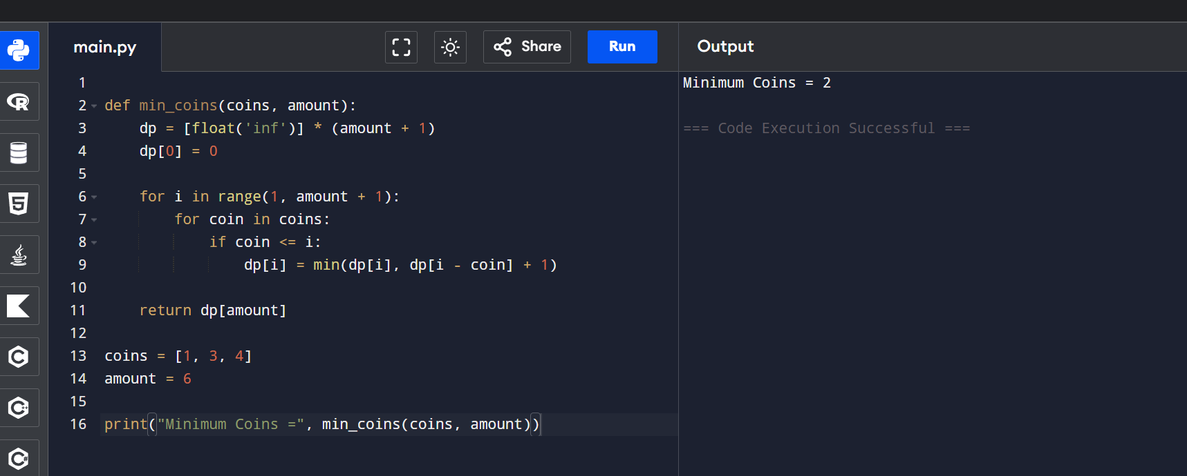
Result
Minimum Coins = 2
(3 + 3)

Q78. Warshall vs Floyd’s Algorithm (Reachability vs Distance)
Aim
To compare Warshall’s Algorithm and Floyd’s Algorithm, analyze their objectives, Dynamic Programming (DP) formulations, matrix usage, complexity, and applicability in graph problems.
Algorithm 1: Warshall's Algorithm
Input
Adjacency Matrix A
Output
Transitive Closure Matrix T
Algorithm
Warshall(A, n)
1. T ← A
2. For k ← 0 to n-1
For i ← 0 to n-1
For j ← 0 to n-1
T[i][j] ←
T[i][j] OR
(T[i][k] AND T[k][j])
3. Return T
Algorithm 2: Floyd's Algorithm
Input
Weight Matrix D
Output
Shortest Distance Matrix
Algorithm
Floyd(D, n)
1. For k ← 0 to n-1
For i ← 0 to n-1
For j ← 0 to n-1
D[i][j] ←
min(D[i][j],
D[i][k] + D[k][j])
2. Return D

